**Bug on Page ‘my.bonify.de’:**

**Issues 6:**

On '**https://my.bonify.de/login?next=/**' Page, 'Data Protection' should be in one line. Some Pages it's on one line and rest in 2 lines, so there should not be any inconsistent behaviour.

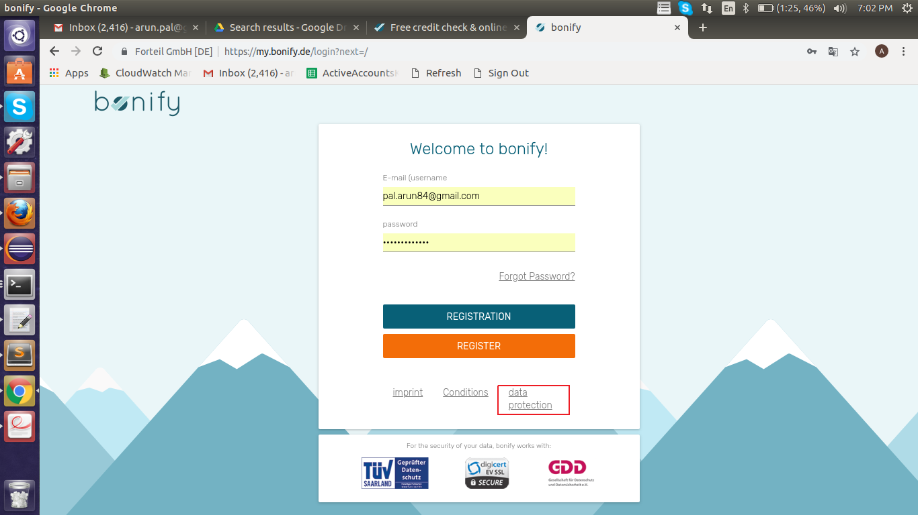

**Steps To Reproduce:**

1: Start Chrome Browser with url **‘https://my.bonify.de/login/’.**

2: Observe the ‘data protection’ Link at bottom of the page.

**Note-** In Few page ‘data protection’ Link is displayed in one Line. (After Login, Forgot Password Page)

**Expected Result:** The link ‘data protection’ should display in one line.

**Actual Result:** Currently in some pages ‘data protection’ displaying in two lines.

**Browser:** Chrome (Version 70)

**OS:** Ubuntu (16)

**Priority:** P4

**Assign To :** Developer.